1. Provide details about the following commands?
- apt-get
the apt-get command is used to install, remove, and perform other operations on installed software packages.
- Yum
YUM is a software package management utility used in many popular Linux distributions, including Fedora and CentOS. YUM is a front-end for the RPM package manager, meaning that it manages packages in the .rpm file format.
- Wget
wget is an important tool on Linux systems if you want to download files from the internet. The program allows you to download content directly from your terminal.
- Gzip tar
Gzip and tar are both linux compression utilities that compresses the file seamlessly. Gzip and tar also used simultaneously.
Syntax for gzip:
Gzip [option] filename

- Rar
It is a archive file format that supports data compression. The command used in linux to extract files from this format is ‘unrar’.

2. Find and Execute following commands in Linux Shell?
- show architecture of machine
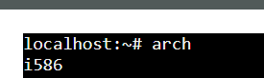
- show CPU info
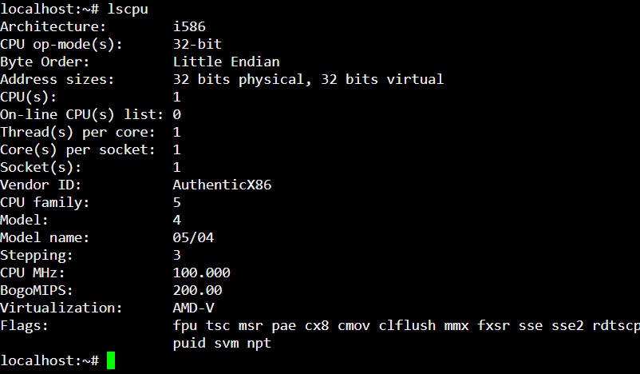
- show version of the kernel
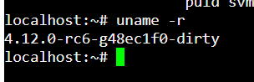
- show system date
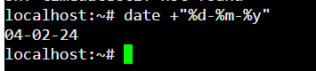
- set date and time
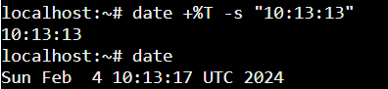
- show details of files and directory
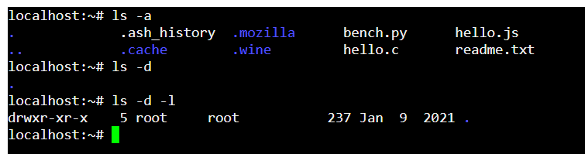

- show hidden files
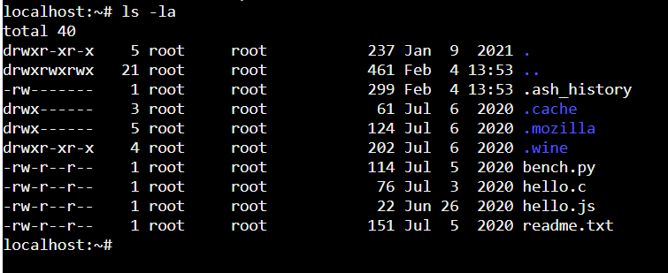
- show files and directory containing numbers
- create a directory called 'dir1’
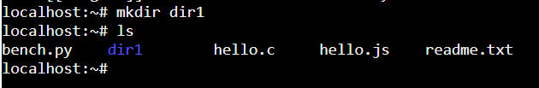
- create two directories simultaneously
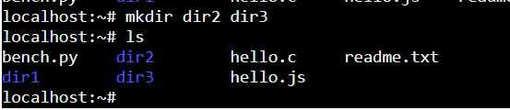
- show the path of work directory
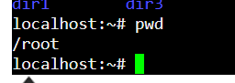

- delete file called 'file1’

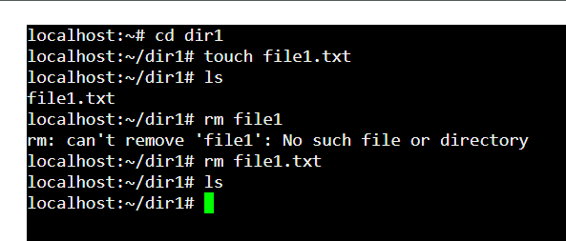
- remove a directory called 'dir1' and contents recursively
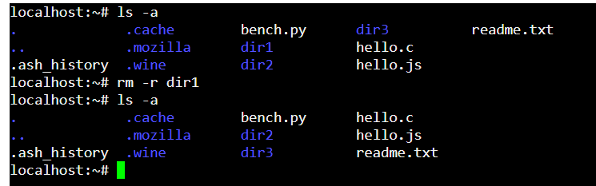
- delete directory called 'dir1’
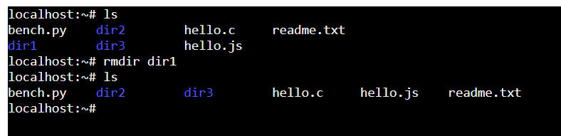

- modify timestamp of a file or directory

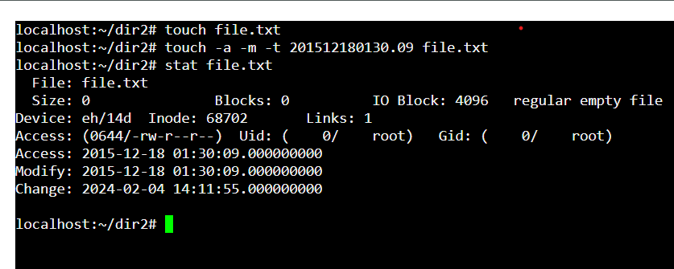
3. Install VirtualBox on your home machine.
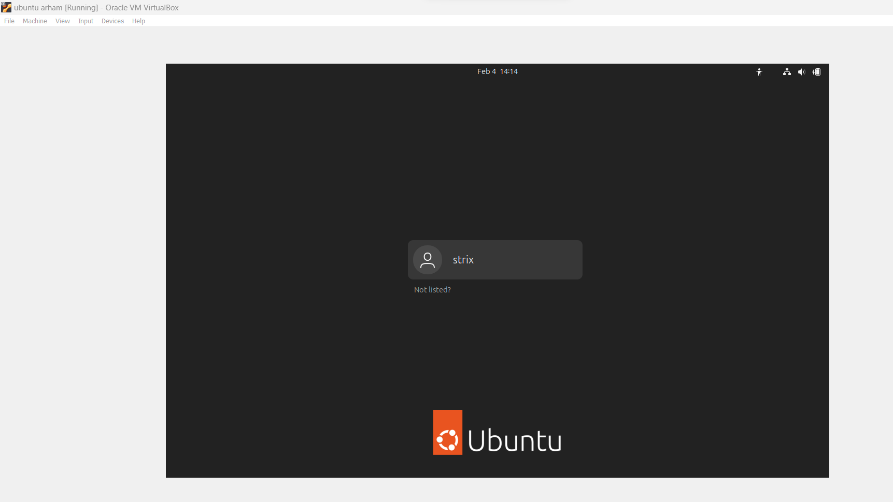
Installed and configured.

